Commercialization Plan Summary

Background

Frollz is a startup company that aims to bring new instantaneous ice cream to the general consumer market. It was established in the US in 2015 and was the first thai ice cream shop in the state of Massachusetts. It opened its second branch in Bentley, Boston in summer 2017.

In parallel, Frollz has opened its first Lebanese branch in May 2017. The concept came out to light as a fixed outdoor booth in Jbeil Souk, Main Street (Pic 1).

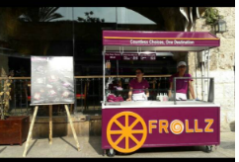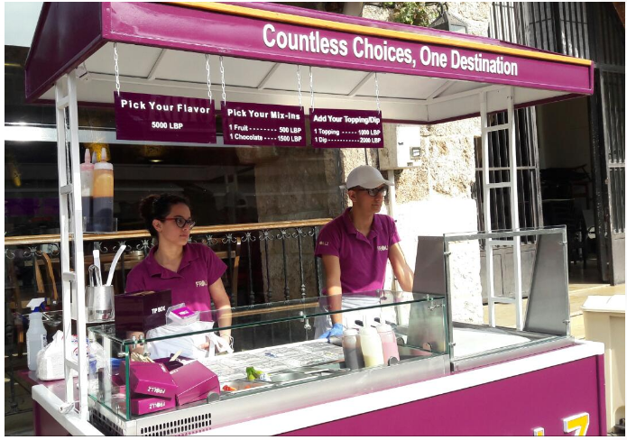
Figure 1- Frollz Booth in Jbeil
Frollz has also participated in a number of events and festivals to increase its exposure among the Lebanese consumers (Pic 2)

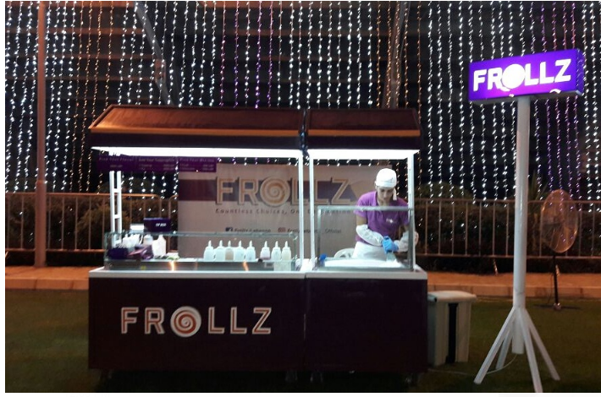
Figure 2- Frollz In Jounieh

Frollz- Lebanon has witnessed a huge success and is looking forward to expand and create new markets. Thus, providing a sustainable location in one of the Lebanese Malls has become a priority.

Product Description:

Our ice cream product is made on the spot in front of the customer in a lively and engaging approach. The customer will have the option to combine virtually any type of fruit with their favorite ice cream flavor and specialty toppings during the making process. The process begins by squashing a fresh whole fruit/Chocolate onto a cold (-30⁰ C) flat pan surface. The liquid ice cream is then dipped onto the crushed fruits along with other toppings, which can include Oreo, nuts, chocolate, etc. The technology uses a “shock freeze” method to instantaneously transform the fruit and liquid ice cream mixture into thin ice cream layers. The layers are then peeled off into rolls and placed in the serving box. The process results in 4 to 6 ice cream rolls corresponding to one serving and normally takes 2-3 minutes.
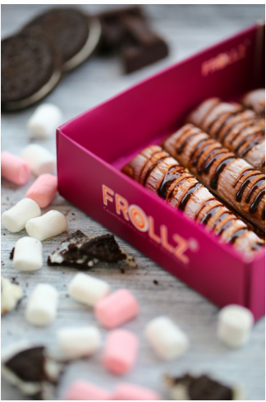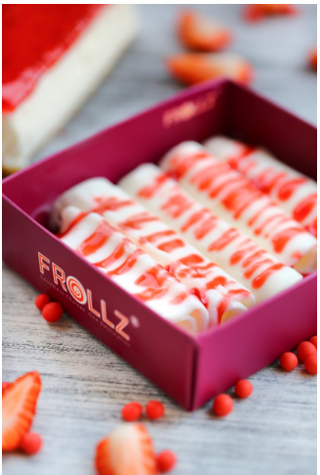
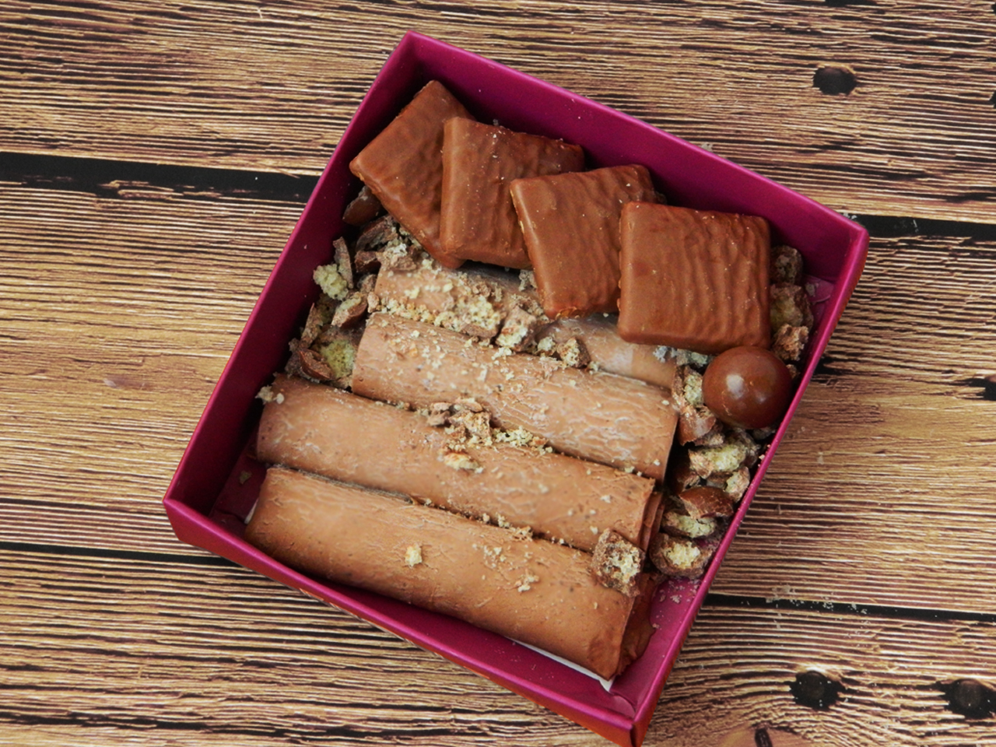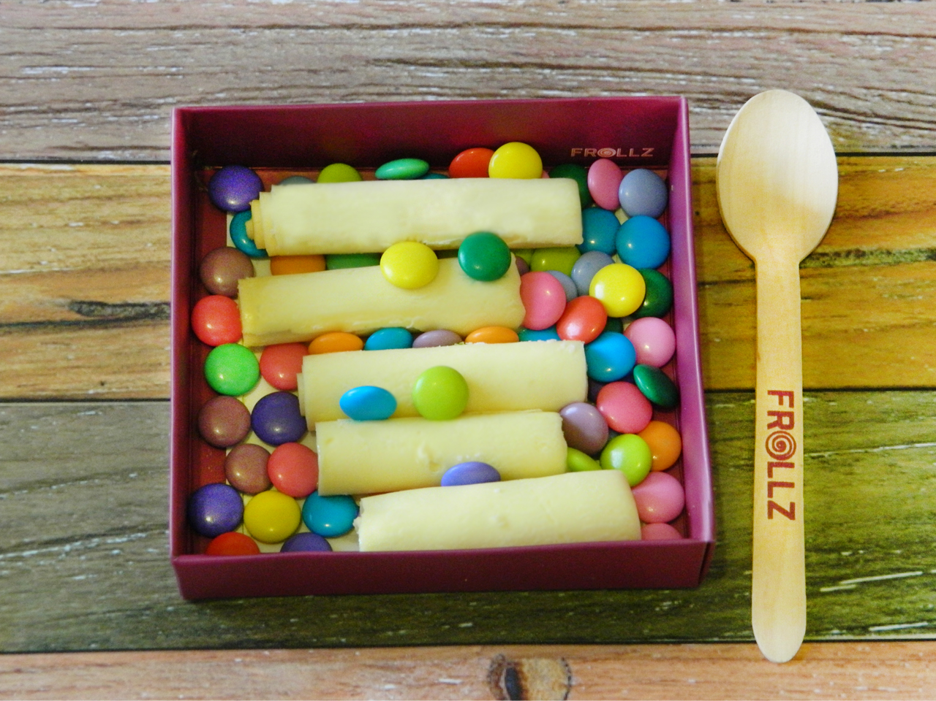

Short / Long-term Sale Plans:

With a unique product offering, Frollz plans to establish its presence at malls and hubs with a strong foot traffic exposure. The impulsive product will target families with kids, young people, and general shoppers. The ice cream will be sold per serving, with a starting price of $5, in a package containing up to 5 rolls.

Competition / Advantages / Risk Assessment:

Our innovative product is expected to differentiate itself from the competition, with a room to add new blends, fruits, and flavors in response to shifting customer needs. The product will mainly compete with frozen yogurt and traditional ice cream. Frollz will strive to meet the highest standards of excellence with a great service in a friendly and smoothing atmosphere. We will also integrate the latest technologies into our point of sale, which engage our customers with follow-up reviews and gift cards to ensure their highest level of satisfaction. Our motto will be: Countless Choices, One Destination

Environmental measures and Food Safety:

Frollz is going green through the use of ozone friendly gas: R410A and avoiding products that generate waste materials that take more than a year to decompose in landfills by adopting wooden spoons and paper boxes

Frollz is fully committed to provide ice cream products that comply with customer requirements for food safety in terms of personal hygiene and good practices.
In addition to ensuring a well cleaned counter space at all times, we will follow a comprehensive cleaning procedures to meet the highest levels in food safety requirements.

Our booth will feature an NSF approved three-compartment sink for washing, rinsing and sanitizing our hand-held equipment, such as putty knives, tweezers, spoons, knives, etc.

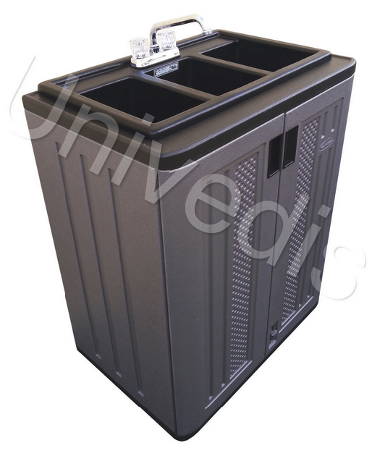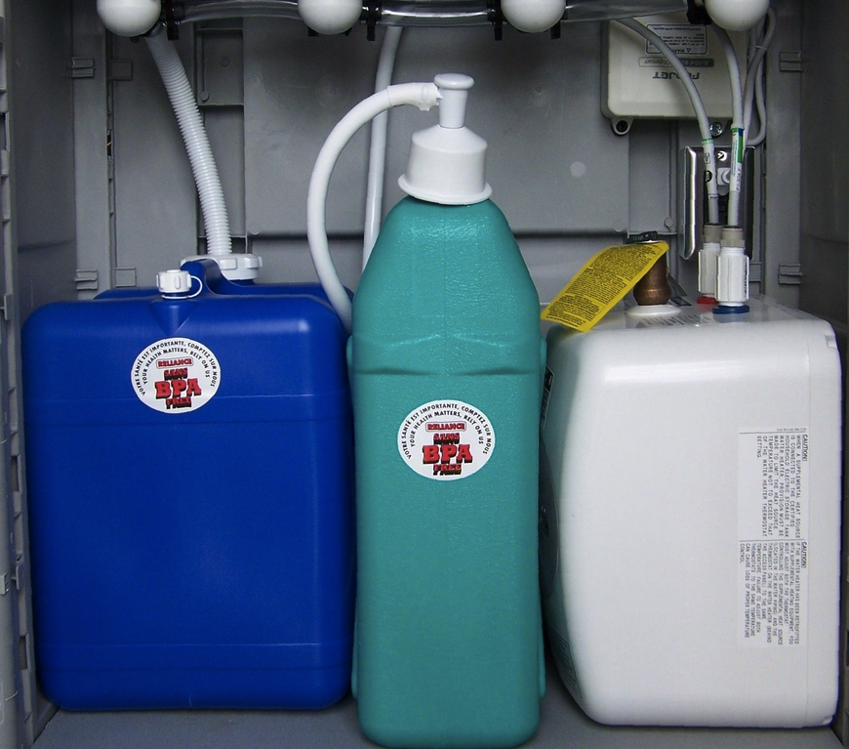
Fig. 9

